TABLE OF CONTENTS
CHANGE CONTROL 1
1. OBJECTIVE 1
2. SCOPE 1
3. TERMS AND DEFINITIONS 1
4. REFERENCE DOCUMENTS: 2
5. DESCRIPTION 2

CHANGE CONTROL
Item | Description | Date | Approval Cycle
1 | Creation of the document | 2/3/2023 | Created By:  Angélica Martínez  Reviewed By:  Andrés Pirela  Approved By:  Andrés Pirela
2 | Content update | 20/05/2024 | Created By:  Andres Pirela  Approved By:  Juan Benavides

OBJECTIVE
To indicate the steps to request contracts for an agent with OSCAR, as well as to complete the contract information in Salesforce.

SCOPE
Applies to agents requesting the Oscar contract through the ARC for the first time or requiring an add state.

TERMS AND DEFINITIONS
ARC: Platform that allows viewing the agent's book of business, production, and commissions.
Carrier: Insurance company or entity with which Claro Insurance maintains contracts, and through these, agents associated with us sell their products.
Salesforce: Digital tool that contains information about the company's agents and clients.
Agency: Organization recognized by Oscar as the recipients of commissions.
GA: Organization to which Override payments are directed.
Commissions: Payments made by the Carrier for the membership and belong to the agent.
Opportunities: Is a term that refers to the individuals requests of contracts, they are located in the opportunities object in Salesforce

REFERENCE DOCUMENTS:
Alliant es un Carrier que opera únicamente en el estado de Georgia y ofrece productos de ACA, el upline para Claro Insurance es Messer Financial, adicionalente es ofrecido a través del programa MBO bajo el NPN de Gamil Kharfin quien es el principal de la agencia All Insurance.

DESCRIPTION
Steps to request the Alliant contract in Georgia:
- Log in to Salesforce and find the contracts requested for Alliant as below:
(1) Click on Opportunities
(2) Choose the started contracting list
(3) Look up for the “Alliant” opportunities.

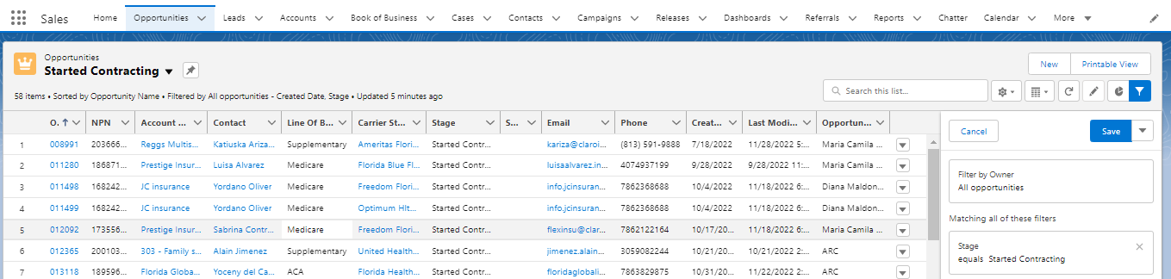

- Open the opportunity to quickly and easily access all the information.
- You must log in to the SureLC portal of Claro Insurance provided by Messer Financial. To do this, follow these steps:
  - Ingresar al portal de agencia a través de:
https://accounts.surancebay.com/oauth/authorize?redirect_uri=https:%2F%2Fsurelc.surancebay.com%2Fbga%2Foauth%3FreturnUrl%3D%252F&client_id=bga&response_type=code
- Log In with the following credentials:
User: contracting@claroinsurance.com
Password: Claro2023*
  - Verify that the agent is already registered in the SureLC portal. To do this, search for the agent by first or last name, which may result in two possibilities:
    - Exist already.
    - Doesn’t exist.
- If the agent does not exist in the portal, you must create the profile by following the steps in the SureLC user creation guide located in:
https://sites.google.com/claroinsurance.com/sig/inicio/cm-pr-01-contrataci%C3%B3n-de-agentes-con-carriers?authuser=0
- Once the agent's profile is created and the initial Messer contract is completed, proceed to request the Alliant Carrier contract. From the Claro Insurance agency's SureLC portal, search for the agent and enter their profile by clicking on their name.
- Once in the profile:
- Click on the "contracting request" tab at the options' far right end.
- Once in the "contracting request" tab, click on "create request" at the top right.
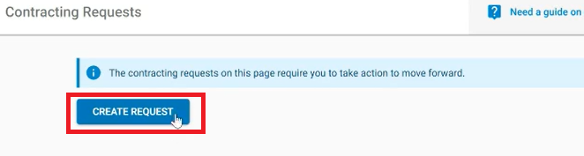
- A dropdown list will appear. Select "Alliant" and "Contract
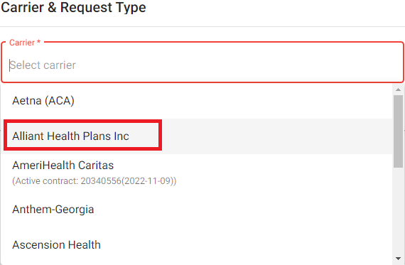

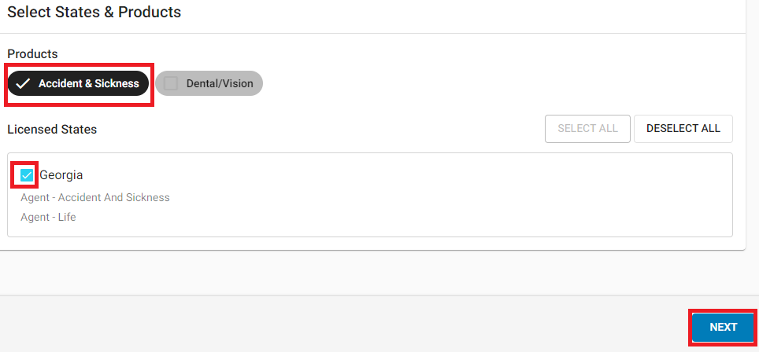
- Select "Group Life & Health" and choose the state to request that the system allows the agent. Remember to select only the states where the agent has an active license:

- Click on "Next" on the following pages that will be displayed.

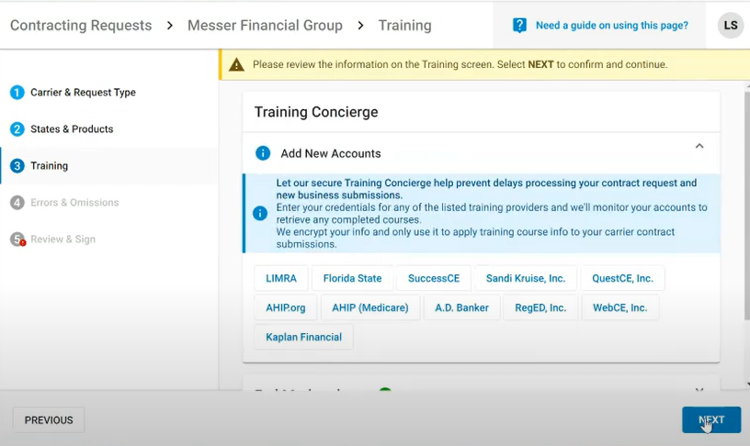

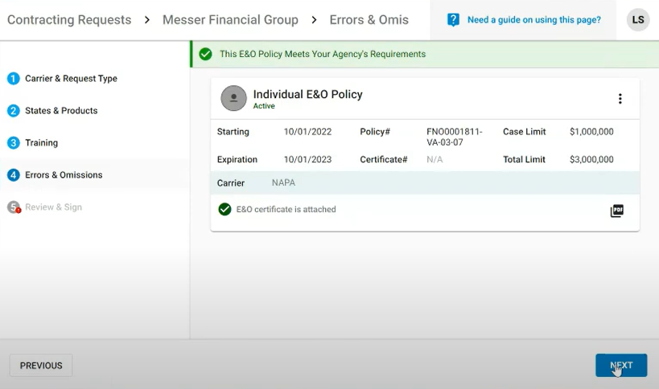
- Carrier Questions, you will need to answer the questionnaire:

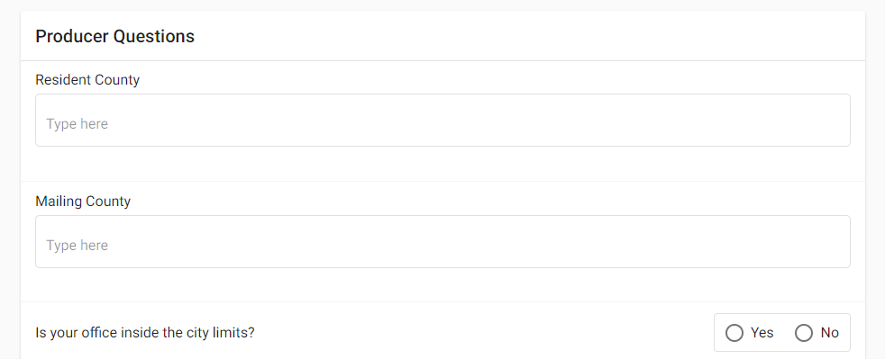
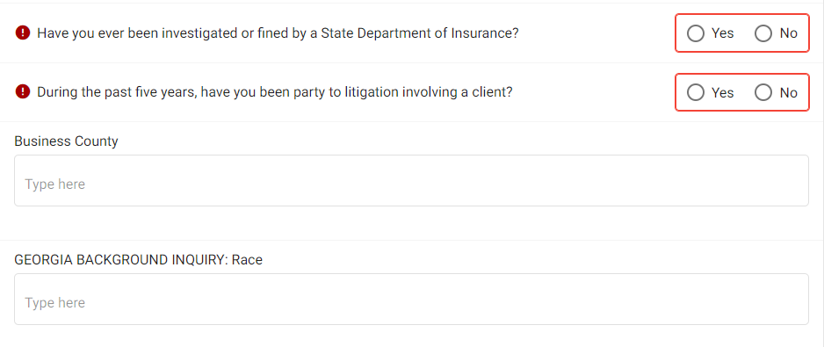
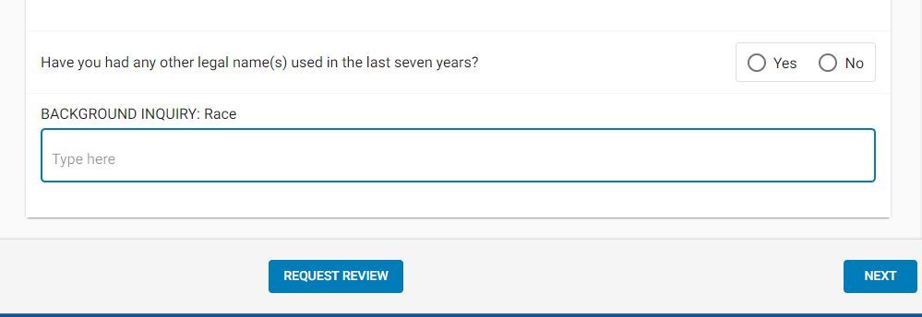

- In the next step, you'll only need to sign the contract with Messer. To do this, scroll to the bottom of the page so that the button becomes active.

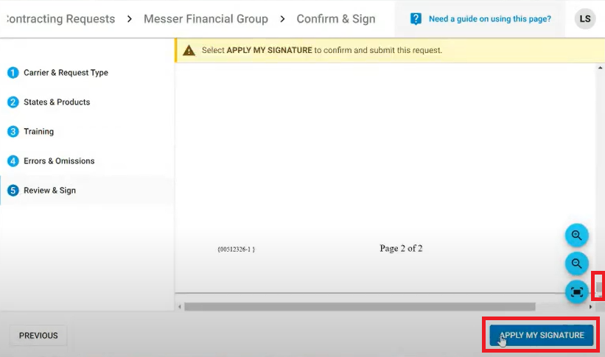
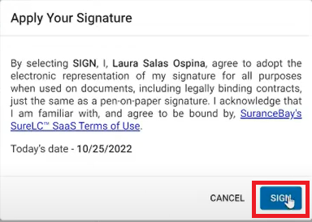

- Choose whether to save a copy of the contract you just signed or not.
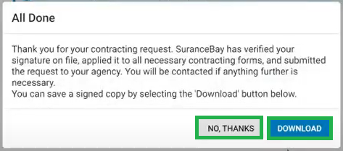
- Go back to SF and change the opportunity that has just been managed to the "Carrier Confirmation" status with its respective note, taking into account the language of the agent.
- The next thing you will receive is a welcome email within one to three weeks, letting you know that you are ready to start selling.
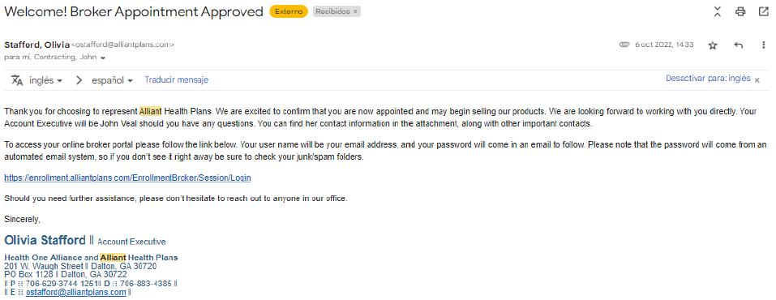
- Once the email to the agent or to us has been confirmed to be sent, we can change the status of the opportunity to "converted" with its respective note and correct completion of the contract where the Writing Number is the agent's NPN.

